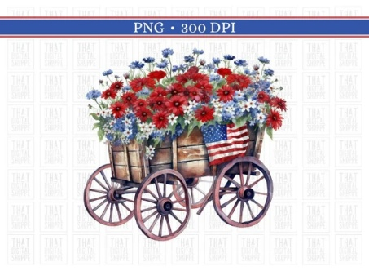

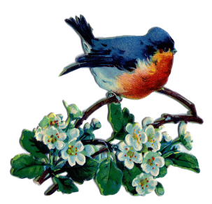**July/August/September 2025**

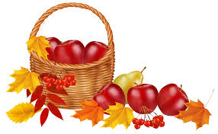**Our ministry vision for the Virginia Annual Conference is *“to be disciples of Jesus Christ who are lifelong learners, who influence others to serve.”***

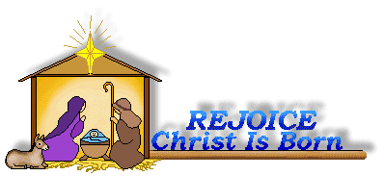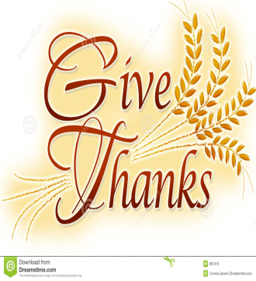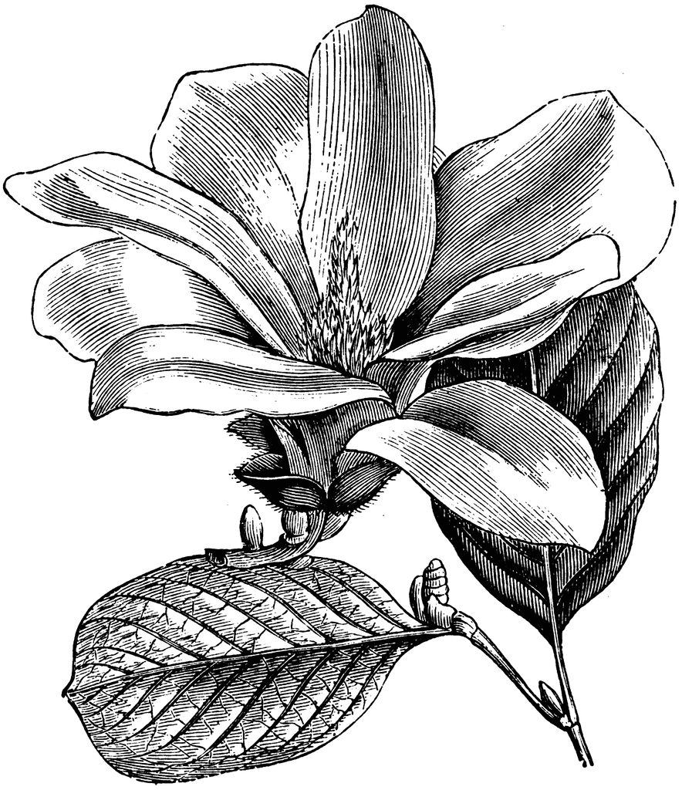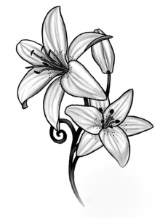

**From Pastor Adam**

***“Leaving a Legacy”***

*Nothing comes from nothing*

*Nothing ever could*

*So somewhere in my youth or childhood*

*I must have done something good.* (“Something Good” – The Sound of Music)

*Then we your people, the flock of your pasture,*

*will give thanks to you for ever;*

*from generation to generation we will recount your praise.* Psalm 79:13

Sometimes we ask ourselves the question: “What kind of legacy am I creating?” or “What sort of impact have I made in the world?” Because as humans we long for purpose, the question of our impact is never too far from us. I have often thought (and preached) that when we are in Christ, when we are aware of our blessed state of being God’s children, then the good fruits we would normally wish for ourselves flows from us even when we are not thinking about it. It becomes somewhat automatic, if you will. The Latin philosophical term *“habitus”* refers to a person’s character, disposition, or way of being in the world. Our *“habitus”* (from which we get the word “habit”) is formed by our experience and personal practice. When we experience the abundant compassion and great mercy of God in Christ, we are changed, such that mercy and compassion become our *habitus*. As we sow good seeds of mercy into the world, sometimes we forget the good we have done simply because it has become a habit for us – imbedded in our daily actions even without our conscious attention to it. Like a pebble thrown into a still pond of water, the

good we create generates ripples that move out from the moment into the lives that are touched by that good. This means that sometimes the only way to measure progress as people, communities, and churches is to look back upon our history. Soon we will have an opportunity to do just that. Fifty years ago, Chestnut Hill hosted and helped to resettle the Vu family who arrived to the US from Vietnam as refugees following the Fall of Saigon. The Vu Family has thrived throughout the years here in the United States, and they have flourished in their personal and professional lives, passing on the good and creating their own life-giving ripples branching out into world around them. Two representatives of the Vu family – Phap Vu and his nephew Do Nguyen (and their wives) – will be with us on Sunday, September 21, to commemorate and celebrate this important 50 year anniversary. I hope you will be able to join with us. I trust this will be a rich opportunity to look back in gratitude and rejoicing. In fact, this reminds me

of those moments when in searching the house for something else, we rediscover yet another beloved treasure.

  God bless you my friends, Adam



**Save the Date**

On Sunday, September 21st, we will celebrate the 50th Anniversary of the arrival of the Vu Family in Lynchburg, following the end of the Vietnam War. A catered lunch will be served following worship, and we hope you will be here for a special day.  More information will follow, so save the date and plan to attend.

**Thank you, Erin**

We would like to take this opportunity to thank Erin Long for serving as our Associate Pastor for the past 3 years. We thank her for sharing her time, talents, and working with the congregation. We wish Erin the best in her future endeavors. We are delighted that she will continue to be a part of the life of Chestnut Hill.”



***GRADUATES...***

***Noah Richardson***, Grandson of Dan and Judy Robertson, graduated on May 13 from J. Sargent Reynolds Community College in Richmond. He will be attending Virginia Commonwealth University in the fall.

***Abby Cook***, Great Niece to Charles & Pat Moore, graduated from Timberlake Christian High School. Will be attendng Liberty University.

***Sara Smith***, Niece to Charles & Pat Moore, graduated from Liberty University. Masters in Business.

***Bryan Patrick Jessen***, Grandson to George & Linda Jessen, graduated from Patrick Henry High School. Will attend Virginia Tech.

***Ayden Brooks***, Grandson to Cliff and & Betty Taylor, graduated from Destrehan High School in Kenner, New Orleans. Will attend a Trade School in the Fall.

***Anne-Elaine Tiller*** graduated from the University of Virginia.  She earned her master's in athletic

training.  She is the daughter of Kirsten and Bryan Tiller. She is the granddaughter of Elaine Clarke.

 Circle News

The Merry Marthas Circle will meet on July 24th at 11:30 a.m., at Charley's, as Camp Meadowlark will be using the church. No business is planned other than collecting dues. We will just enjoy lunch together. August 28 and September 25 meetings will be at church as usual at 10:30. Please let me know if you would be willing to present a devotional or have an idea for a program on those dates. ~*Judy Robertson*

The Wesleyan Group will **not** meet in July. We will resume on Mondays, August 11, @ Hunt Home and September 8 @ Robbins home, at 7:00 p.m. *~Ann Robbins*



**The choir** will be singing on Sundays, July 13 & 27. We will be rehearsing at 10:00 a.m. August and September will be announced later. We will sing familiar hymns so come join us! *~Sharon Mayhew*, Director of Music

**Food Cart: July/August/September**

***Side dishes for a holiday meal***; stuffing, cranberry sauce, instant potatoes, canned vegetables, etc. **AND** emergency food bags items, such as snack crackers, small cans of beans, cans of pasta products, fruit cups, and food products that don't require refrigeration. **Pop-top** cans only!

*No* ***“baked goods”****!* *Place donations in the grocery cart, located in the Commons*.

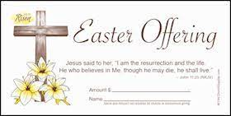**Easter Offering**

Update. Your donations for our Easter offering totaled $4,520.00. Thank you for your

continued support of our ministries.

**Friends Who Care**

We are resuming our *“Friends Who Care”* program. For participants please send your reports of visits and phone calls each month to **Scottie Nuckols**, 1250 Jefferson Oaks Court, #44, Forest, VA 24551. Or email her to [mx55566@gmail.com](mailto:mx55566@gmail.com). On your report please note the month and year, names of those visited (or called) and the number of times visited or called with any comments by the pastor. Please try to get this information to Scottie by the **5th** of the month. We express our appreciation to all the volunteers who participate in this ministry of compassion. If you would like to volunteer contact Scottie Nuckols.

*Many thanks to the congregation* for the nice wellness cards with all the signatures and notes of good wishes.  I miss Chestnut Hill UMC and each of you very much.  Please keep me in your prayers and come to visit when you can. ~Love and Blessings, *J. Owen*

*Stinnette*

*We would like to take this opportunity to thank you* for all the love you have shown us during Eleanor’s illness and death. The prayers, cards, phone calls, and all the kindnesses that you gave us is so greatly appreciated. Our Chestnut Hill family is, and will always be, in our

thoughts and prayers. Sending you love from our hearts.

~Love always, *Bob Elium, Donna, Sandra, and Robert, Jr.*

Missions Report

We collected 86lbs. of food items for Park View Mission this quarter. Our participation in this out reach mission benefits neighbors who may be struggling. Thank- you to all who donate to this mission.For July, August, and September we will collect items for side dishes for a holiday meal; stuffing, cranberry sauce, instant potatoes, canned vegeta bles and anything you can think of for a special meal. Also we will collect items for emergency food bags, such as snack crackers, small cans of beans, cans of pasta products, fruit cups, and food products that don't require refrigeration. All the cans must have pop tops. Thank you for your support. ~Thank you, *Linda Jessen & Mission Committee*



1 Pat Short

2 Nancy Lee

Emily V.

Fernandez

3 Michael McGlothlin

6 Kirsten Bell

Tim Crist

Dennis Tolley

7 Kenny Busic

Cheryl Powell

9 Owen Stinnette

Jeremey

VandeBogart

11 Landen Glass

12 Camden Mason

14 Wade Ware

16 Burton Brooks

Terry Palazzi

Anne-Elaine Tiller

17 Suzanne

Marshall

Blake Phillips

18 Sharon

Rickmon

19 Connie Yost

20 Erin Ecklund

21 Steven Kinzer

22 C.O. Bell

25 Frankie

Hardwick

28 Jacqueline Busic

Cheryl Thomas

29 Wes Robbins

Ricky Smith

31 Robert Baunach

**2022**

**March 2022**



*Chestnut Hill United Methodist Church extends Christian love and sympathy* to the family of *Eleanor Elium,* and especially to her husband, Bob, and her children, Sandra, Donna, and Bob, Jr. Mrs. Elium passed away on May 14, 2025.

*To the family of Betty Enochs* and especially to her sister-in-law, Scottie Nuckols. Mrs. Enochs passed away on June 11, 2025.

*And to the family* of *Warren Martin*, and especially to his brother, Dennis Martin, and wife, Judy. Mr. Martin passed away on June 16, 2025.



*We welcomed into the membership of Chestnut Hill UMC* on Sunday, May 11th, *Paul and Ann Compton*. They reside at 1009 Misty Mountain Rd., Apt. 1304, Lynchburg. VA 24502

*Gifts & Memorials*

In Memory:

*Eleanor Elium*

Given by: Sylvia Boyd, Scottie Nuckols, Frances Unruh, Dan & Judy Robertson, George & Susan

Beasley, Merry Martha’s Circle, Laird Ramsay, Alice “Lee” King, Larry & Gail Hoke, Monica Campbell, Fred & Sue Norvelle, Gary & Amy Shelby, Teresa Holland-Gresock

*In Honor:*

*Bob Elium*

Given by: Gary & Amy Shelby



**GOOD NEWS** will be published quarterly. Pick up your copy in the Commons or watch for it on our website: www.chestnuthillumc.net.

**Our Church Financial Picture**

Through the end of June 2025

General Operating Funds:

Needed to meet our 2025 Budget $ 200,803

Needed to meet our budget to date $ 100,402

Actual receipts to date $ 77,145

Shortage to meet budget to date $ 23,257

Actual expenditures to date $ 77,722

Shortage to meet expenses to date $ 577

Special Offerings* (not budgeted):

Received to date $ 6,595

Dispersed to date $ 5,330

*Christmas, Easter, Annual Conference,

World Communion, etc.

Thank you for your generosity.

**~Those Who Serve ~**

**JULY GREETERS**

July 6 ~Jane White

July 13 ~Mary Walker

July 20 ~Judy Robertson

July 27 ~Maggie Musgrove

**AUGUST GREETERS**

August 3 ~Dan Robertson

August 10 ~Betty Taylor

August 17 ~Judy Robertson

August 24 ~Ann Robbins

August 31 ~Maggie Musgrove

**SEPTEMBER GREETERS**

September 7 ~Ann Robbins

September 14 ~Betty Taylor

September 21 ~Jane White

September 28 ~Judy Robertson

**Birthdays…**

**Septembe**r

4  Jimmy Blunt

Adna Fainter

5 Shirley Johnson

8 Monica Campbell

9 Mintcy Maxham

11 Robert Hicks

12 Clarissa Clarke

14  Robert Elium, Jr.

15 Sylvia Rose

Jody Underwood

18  Robert Bennett

Sarah Stables

19 Thomas Evans

Linda Stinnett

21 Naomi Levin

22  Eleanor Maxham

23  Mary Walker

24  Hannah White

26  Jessah Klein

Sharon Mayhew

29  Beverly Franklin

Chet Walker

***August***

1 Betty Taylor

2 Greyson Glass

4 Colby Takacs

5  Braelyn

Underwood

11 Pat Wood

14 Roy Quick, Jr.

16 Nancy

Heptinstall

17 Sara Klein

18 Elaine Maddy

20 Michael Jessen

22 Judy Robertson

23 Valerie Witt

24 Wayne Everidge

25 Laura White

26 John Hodges

31 Katie Bradley

Fred Norvelle

**July**

1  Al Wood

4 Devin Beiler

Pam Croft

5 Wilton Burgess

6 Judy Martin

8 Connor Burgess

10  Rev. Rick Ecklund

Rachel Glass

11 K.J. Ruhland

13 Paisley Klein

20 Pete Witt

21 Linda Wingfield

25 Carrie Smith

27 Melanie Jay

Fred Shafer

29 Megan Carr

30 Ann Robbins



***DIRECTORY OF***

***CHESTNUT HILL UNITED METHODIST CHURCH***

|  |  |  |
| --- | --- | --- |
|  | Sue Haupert-Johnson | Richmond Area Resident Bishop |
|  | Rev. Dr. Sarah Calvert | Mountain View District Superintendent |
|  | Adam White | Minister |
|  | Monica Campbell | Administrative Assistant |
|  | Sharon Mayhew | Director of Music Ministry |
|  | Judy Martin | Bookkeeper |
|  | Judy Robertson | Lay Leader |
|  | Elizabeth Nichols | Missionary in Henry County |

**Calendar of Events**

**Sundays**—Sunday School, 9:30 a.m. ~ Worship Service, 10:30 a.m

**Fridays** –Homeschool, 10:00 a.m.

***July***

***June 30-July 25***  ~Camp Meadowlark (Monday-Friday), 8:30 a.m.

***Friday, July 4 ~****Independence Day* ~Office Closed

***Mondays, July 7, 14, 21, 28*** ~Camp Meadowlark Line Dancing , 6:00 p.m.

***Thursday, July 24*** ~Merry Martha’s Circle @ Charley’s, 11:30 a.m.

***August***

***Saturday, August 9***~Homeschool Open House, 9:00 a.m.

***Monday, August 11*** *~*Wesleyan Group *@* Hunt Home*,* 7:00 p.m.

***Tuesday, August 12*** *~*Homeschool Game Night*,* 7:00 p.m.

***Friday, August 15***  *~*Homeschool Meeting*,* 12:00 noon

***Thursday, August 21*** *~*PEO Craft Activities (TBA)

***Friday, August 22***  *~*Homeschool-First Day of School*,* 10:00 a.m.

***Thursday, August 28***  ~Merry Martha’s Circle, 10:30 a.m.

***Friday, August 29*** ~Church Office Closed

***September***

***Monday, September 1*** ~*Labor Day* ~Office Closed

***Monday, September 8*** ~Wesleyan Group @ Robbins Home, 7:00 p.m.

***Tuesday, September 9***  ~Homeschool Game Night, 7:00 p.m.

***Sunday, September 21***  ~Vietnamese Homecoming, 11:45 a.m.

***Thursday, September 25***  ~Merry Martha’s Circle, 10:30 a.m.

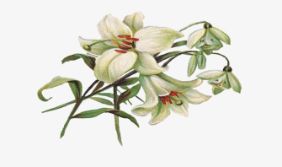

January 2022

**2022**

**April 2022**

**April 2022**

**March 2022**

*Chestnut Hill United*

*Methodist Church*

4660 Fort Avenue, Lynchburg, VA 24502

Phone Number: 434-239-8423: FAX: 434-239-7209

E-mail: [chestnuthillumc@comcast.net](mailto:chestnuthillumc@comcast.net)

On the web: www.chestnuthillumc.net

Church Office Hours

**Monday-Thursday~**9:00 am—3:30 pm**; Friday~**9:00 am-1:00 pm